**ANTHONY** QIU

**EMAIL:** abqiu@uwaterloo.ca **PHONE:** 647-917-8891

**Brake Caliper Mounting Arm for Solar Car**

**How?**

* Fabricated initial prototype using PEX pipe, Nerf gun parts, and duct tape to gauge design feasibility.
* Designed scaled 3D model to prepare team for construction of the design.
* 3D printed unique parts with ABS and machined high stress parts using steel.
* Assembled using force fits and superglue for adhesion.

**What?**

* A spring powered toy rocket launcher, created by a team of 5 people.
* Has the capability to adjust it’s launch angle in all dimensions.

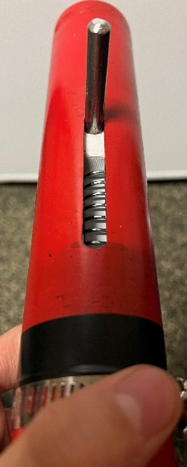

**Results**

* Able to consistently launch its projectile above **1.5m** when angled vertically.
* Can adjust its launch angle in any direction within **20 degrees** from the vertical (upwards).
* Wide base prevents tipping during use.
* An aesthetic design achieved through many CAD revisions and spray painting.

**Launcho**

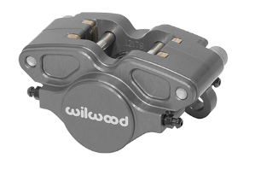

**What?**

* A mounting arm to mount Wilwood’s GP200 caliper to our solar car at Midnight sun.

**How?**

* Designed 3D model of mounting arm in Solidworks, using caliper dimensions obtained from the instruction manual.
* Performed FEA stress test and topological analysis to produce the most effective strength to weight ratio.

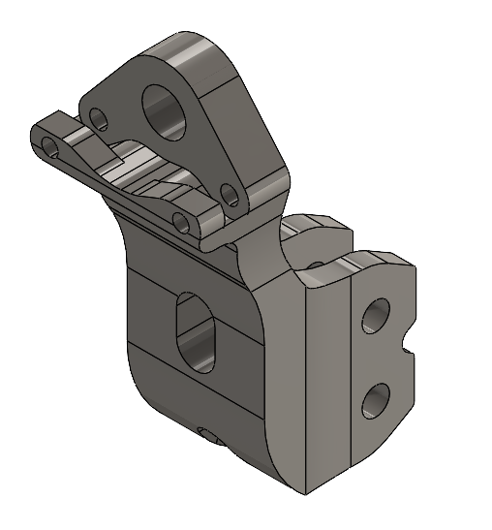

**Results**

* Successfully created 3D model allowing fabrication of the mounting arm.

**Saitama**

**Results**

* A fully functional discord bot which can respond to messages, keep track of user statistics, execute certain commands, and play YouTube audio in voice calls.

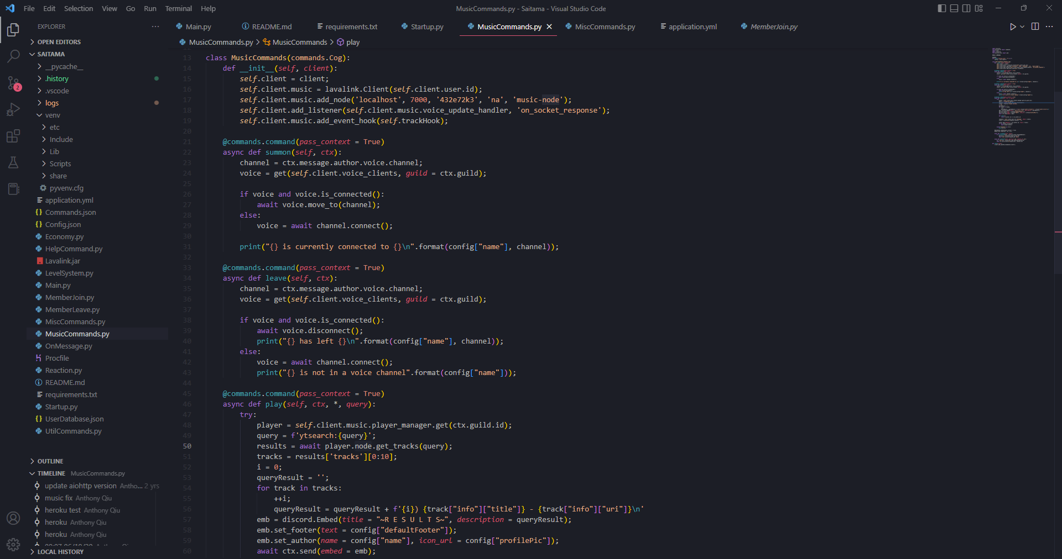

**How?**

* Programmed with python and several libraries for extra functionality.
* Json files were used to store user information.

**What?**

* A server hosted application which can interact with a chat service called Discord.

**What?**

* An impeller and enclosure designed to generate vacuum force for a suction feature on a robotic Lego arm.

**How?**

* Designed 3D model of impeller in SolidWorks.
* Ran flow simulations in Solidworks to determine the most optimal shape for the impeller.
* 3D printed impeller as well as enclosure for impeller using PLA filament.

**Results**

* Generates suction with the use of only **one** Lego EV3 motor and several gear ratios.
* Can generate enough suction to lift a **4 g** object, demonstrated by lifting a napkin.

**Impeller for Robotic Suction Arm**